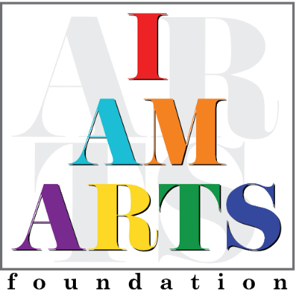

Ahmed Brown, Advisory Board Co-Chair of the I AM ARTS Foundation Board of Directors, brings a depth of strategic experience and a passion for innovation. His career as a management consultant, including time at PricewaterhouseCoopers and Deloitte, has honed his ability to solve complex challenges and drive organizational growth. Currently a Strategy and Transformation Leader at Thought Logic Consulting, Ahmed not only develops innovative solutions for clients but also leads the firm's corporate innovation team, shaping its own future-focused strategies.
Deeply inspired by his late mother, Yvonne James-Brown, a nationally recognized choreographer, educator, and community activist, Ahmed believes in the transformative power of the arts. Having witnessed this firsthand, he champions I AM ARTS as a force for positive change within youth, families, and the broader community. As Co-Chair, Ahmed's strategic vision and innovative mindset ensure I AM ARTS expands its impact, empowering the next generation through creative expression.
A Buffalo native, proud Howard University alum, and dedicated Atlanta resident for over a decade, Ahmed is committed to empowering Atlanta's youth and strengthening communities through the arts.

